**20CYS181 – Computer Programming Lab**

**Lab Evaluation 1**

Answer

1.

Source Code:

#include <stdio.h>

int take(int remain, int taken){

remain = remain - taken;

return (remain);

}

int put(int remain, int put_away){

remain = remain + put_away;

return (remain);

}

int refer(int remain, int number){

remain = remain + (50*number);

return (remain);

}

int main()

{

char chr, buffer;

int bal, check_w, check_d, check_y, with, dep, num;

printf("Enter your account balance (>500): ");

scanf("%d", &bal);

scanf("%c", &buffer);

while (1)

{

printf("\n'W' or 'w' for withdrawal");

printf("\n'D' or 'd' for deposit");

printf("\n'Y' or 'y' for refering your friend");

printf("\n'Q' or 'q' for quiting the process\n");

printf("\nEnter your operation: ");

scanf("%c", &chr);

switch(chr)

{

case 'W':

case 'w':

{

printf("\nEnter the amount to be withdrawn: ");

scanf("%d", &with);

if (bal>with)

{

bal = take(bal, with);

printf("\nAmount withdrawn successfully");

printf("\nThe balance in your account is %d", bal);

}

else

printf("\nNot sufficient balance...");

break;

}

case 'D':

case 'd':

{

printf("\nEnter the amount to be deposited: ");

scanf("%d", &dep);

check_d = put(bal, dep);

printf("\nAmount deposited successfully");

printf("\nThe balance in your account is %d", check_d);

break;

}

case 'Y':

case 'y':

{

printf("\nHow many friends you want to refer: ");

scanf("%d", &num);

check_y = refer(bal, num);

printf("\nThe balance in your account is %d", check_y);

break;

}

case 'Q':

case 'q':

return 0;

break;

default:

printf("\nEnter a valid alphabet for operation");

}

}

return 0;

}

Test Case 1

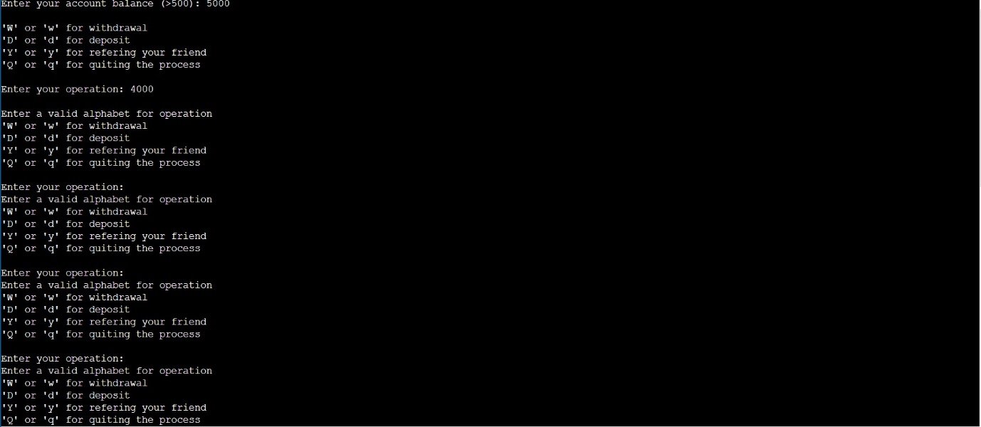

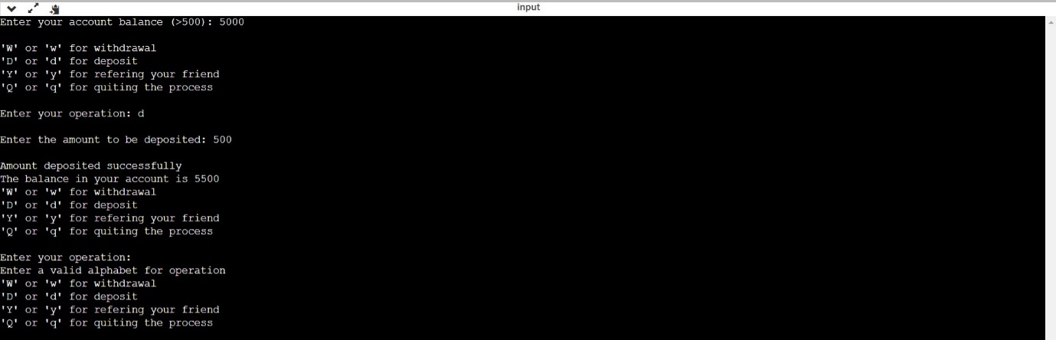Test Case 2

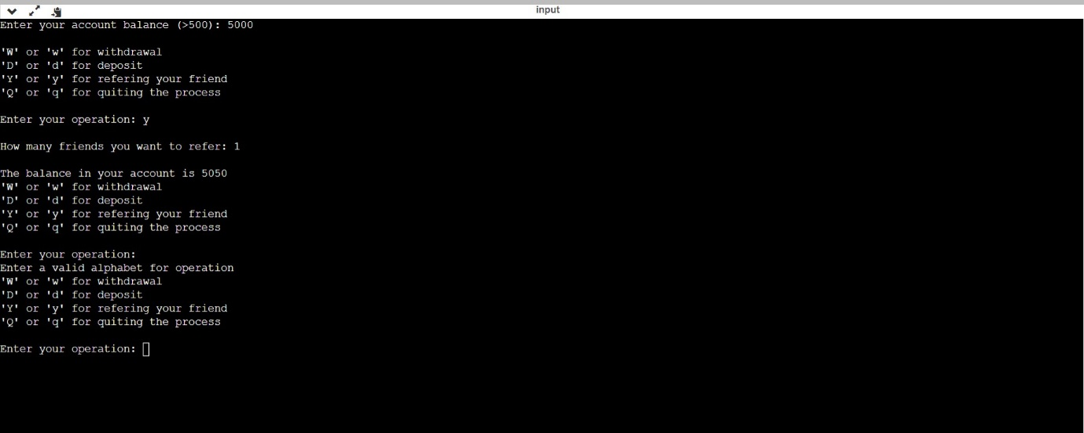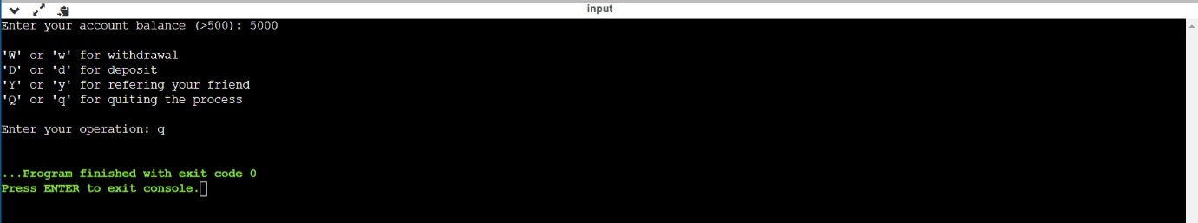Test Case 3

Test Case 4

2.

Source Code:

#include <stdio.h>

int power(int a,int b){

int i, val=1;

for (i = 0;i<b;i++){

val = val * a;

}

return val;

}

int gcd(int a, int b){

int i, val;

for(i=1; i <= a && i <= b; ++i){

if(a%i==0 && b%i==0)

val = i;

}

return val;

}

int chk_prime(int a){

int pr = 1;

int i;

for (i=2;i<a;i++){

if (a%i == 0)

pr = 0;

}

return pr;

}

int prime(int a){

int i;

for (i=2;i<=a;i++){

if (chk_prime(i) == 1)

printf("%d\n",i);

}

return 0;

}

int main(void){

int chr;

int a,b, x = 1;

int answer1,answer2,answer3;

while (x == 1){

printf("\n1 for finding power of a number\n");

printf("2 for finding GCD(HCF) of 2 numbers\n");

printf("3 for printing all primes between 1 and given number\n");

printf("4 for quitting this program\n");

printf("Choose from above options: ");

scanf("%d", &chr);

switch(chr){

case 1:

printf("Enter a number: ");

scanf("%d", &a);

printf("Enter a number: ");

scanf("%d", &b);

answer1 = power(a,b);

printf("%d", answer1);

break;

case 2:

printf("Enter a number: ");

scanf("%d", &a);

printf("Enter a number: ");

scanf("%d", &b);

answer2 = gcd(a,b);

printf("G.C.D of %d and %d is %d", a, b, answer2);

break;

case 3:

printf("\nEnter a number till which prime number is to be printed: ");

scanf("%d", &a);

answer3 = prime(a);

printf("\nThe balance in your account is %d", answer3);

break;

case 4:

x = 0;

break;

default:

printf("\nEnter a valid number for operation");

}

}

}

Test Case 1:

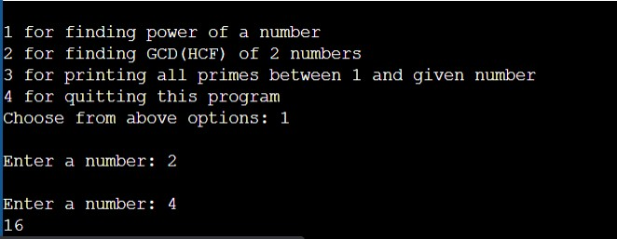

Test Case 2:

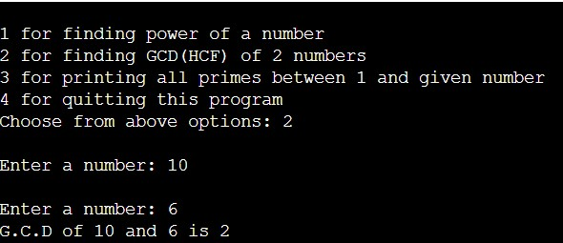

Test Case 3:

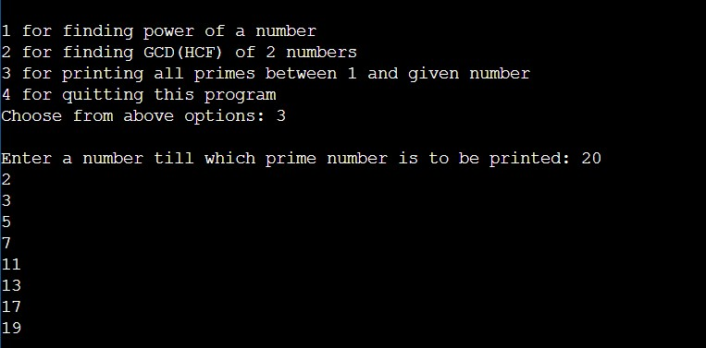

Test Case 4:

